DocEP – Request for Assistance

This form is designed to help you introduce a request for support in case of problems with the installation or use of the DocEP macro.

All fields have to be filled in. Incomplete requests will be rejected.

Instructions

Prior to filling in a request for assistance, please ensure that you have exhausted all possible options in trying to address the problem. All known problems experienced by contractors have been summarised together with their solutions in the document ‘DocEP FrequentProblems’.
Once you have filled in this request for assistance, please send it by email to:
dgtrad.etucontractsexecution@europarl.europa.eu

Prerequisites

I have checked my problem against the list of known problems in the document ‘DocEP FrequentProblems’
I made sure that I am running the installation with administrator privileges
To verify your administrator status:
Go to Settings > Accounts > Your Info
It should read ‘Administrator’ under your name.
My computer is fully up-to-date (all OS+MSOffice updates have been installed), and my computer is virus-free and freshly rebooted.
To verify your computer installation status:
Go to Settings > Update & security > Windows Update > Check for updates;
The Update status should read ‘No updates available’ or ‘Your device is up to date’.

Please send us a screenshot which states you are an administrator, as in the screenshot below:
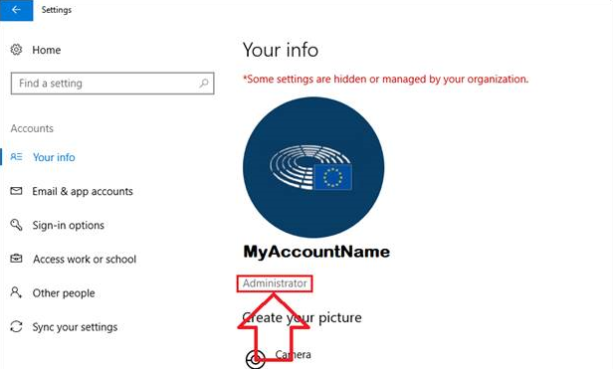

Please send us a screenshot with the update status of your PC, it should look similar to the screenshot below:
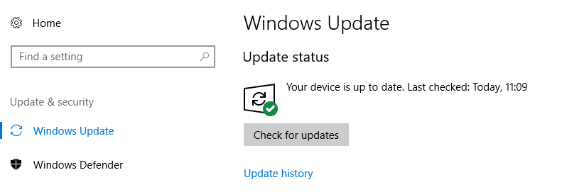

Operating system

Operating System
Version
Language

MS Office / Word version

Version
Language

Please send us a screenshot indicating the version of MS Word. You can find it in File> Account > About Word. It should look similar to the screenshot below:
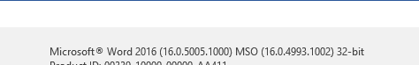

DocEP version

Version
(see DocEP – About)
Registry build
(see DocEP – About
Standard installation?
(if not, specify which changes have been made)

Error description

DOES THE PROBLEM OCCUR ...
On a single PC?
On several PCs?
On all PCs?
Other
(please specify)

DOES THE PROBLEM OCCUR ...
At installation?
During use?
(please specify the function)
Other
(please specify)

ERROR REPORT
Detailed description of the sequence of steps leading up to the problem

ERROR REPORT
Can the problem be systematically reproduced?

Screenshots (mandatory in case of error message)

Please include hereafter any screenshots that might help in troubleshooting the problem.

